Keywords: Exter, pyramid,

## Saturday, November 21, 2009

### [Gold is Wealth](http://fofoa.blogspot.com/2009/11/gold-is-wealth.html)

[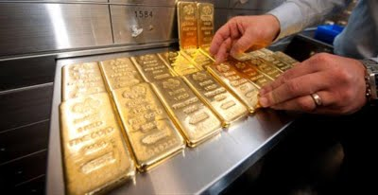](http://1.bp.blogspot.com/_cvdgPlEKW9k/Swhvj_NfbZI/AAAAAAAAA6Q/L5b8PJp7vXs/s1600/1kg_gold_bars_worth_about_37_000_each.jpg)  
Why should we own gold? What is gold good for? What does it mean to say "gold is wealth"? And what exactly *is* wealth? We have contemplated the pure concept of money. [1][2][3] How about the pure concept of wealth?  
  
We all have needs. In fact, we all have the same needs in sustaining our lives. In some things, some of the most essential needs, we are all equally and extremely wealthy. We could even build a pyramid of these needs and their supply relative to our demand for them. In many cases, the most needed things are in such complete supply as to overwhelm demand. No need to hedge against a future shortage of these things through derivatives or swaps. You see, wealth in fact is anything that helps us in meeting our future needs. To have more than you demand for immediate survival is to be wealthy!  
  
Take, for example, the Higgs Boson. Assuming this particle actually exists, it is *the* foundation of all things, of all life. It is something we all need in order to survive! We would simply disappear (or not exist) without it. It is what makes matter matter, so to speak. And again, assuming these things really exists, then there must be plenty of them around. More supply than we demand. Or at least, theoretically, the *perfect* supply to meet demand at all points in time.  
  
[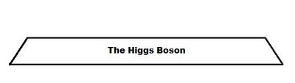](http://2.bp.blogspot.com/_cvdgPlEKW9k/SwhscOxnhRI/AAAAAAAAA4g/BVZz_f3aOtk/s1600/Pyramid_Foundation.jpg)  
Another essential need we all have is gravity! What would you do if you ran out of gravity? Float away? Thankfully we have a plentiful supply of gravity that "outweighs" demand. ;)  
  
[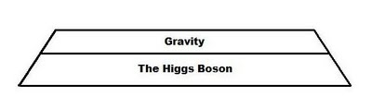](http://4.bp.blogspot.com/_cvdgPlEKW9k/Swht2EotDTI/AAAAAAAAA44/fv_7xixds84/s1600/Pyramid_Gravity.jpg)  
How about sunlight? Are you wealthy in sunlight? Well, we may not all be equally wealthy when it comes to sunlight, but there is no doubt that we all need it to survive. And amazingly enough, supply seems to always meet demand without the need for hedging or storing sunlight for future use.  
  
[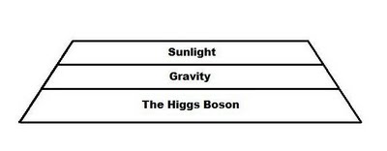](http://3.bp.blogspot.com/_cvdgPlEKW9k/SwhuCF9kRwI/AAAAAAAAA5A/G3DEDlGDVTU/s1600/Pyramid_Sunlight.jpg)  
Moving on up the pyramid we come to oxygen. Yes, there are some situations in which it pays to store oxygen for future use. If you are planning a trip to outer space or, perhaps, to the bottom of the ocean then it would make sense to hedge your bets and load up on more oxygen than you think you might need. The risk:reward ratio highly favors a surplus of oxygen in situations where it is possible for demand to outrun supply!  
  
[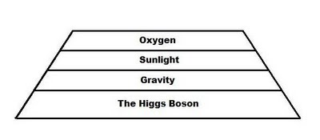](http://3.bp.blogspot.com/_cvdgPlEKW9k/SwhuKTsHhZI/AAAAAAAAA5I/NoajS-pzoXQ/s1600/Pyramid_Oxygen.jpg)  
Topping off the pyramid we have the needs we humans all strive to secure, food, clothing and shelter. And in our modern world of electronics and internal combustion we could also add energy to this list. Under the most extreme conditions, we could probably find wood to burn in the forest for cooking and heating. But who wants to live like [Ted Kaczynski](http://en.wikipedia.org/wiki/Theodore_Kaczynski#Life_in_Montana) (pre-arrest)? Even Mad Max had fuel for his car!  
  
[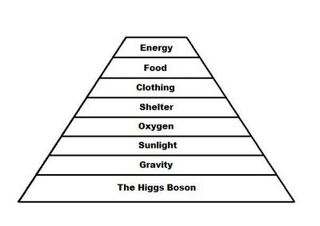](http://1.bp.blogspot.com/_cvdgPlEKW9k/SwhuU73bfcI/AAAAAAAAA5Q/_PnKzx2EnYo/s1600/Pyramid_Energy.jpg)  
But luckily for us, 5,000 years of trade have taught us that we don't need to plan as meticulously for survival as an astronaut or a deep sea diver. As Aristotle [4] explains:  
  
We can generally blunder our way through day to day and year to year in the comfortable fact of life that, through the open market--through the ability to trade with others--we can generally obtain what we materially need in one facet in exchange for some of our own wealth in another facet. Food for clothing seems like a pretty reasonable medieval exchange, doesn't it?  
  
We all know the inefficiencies of barter, don't we? As civilization and trade evolved from the dawn of man to the 20th century, Gold revealed itself to be the single most reliable, universal agent that could be traded in various quantities for anything anywhere on Earth. Maybe most remarkable in this is that Gold is not itself something that is needed or consumed in satisfaction of our basic material needs for survival. But due to it being perfectly and uniquely suited for this universal role in trade for any other person's available wealth as necessary to meet our own specific needs, Gold has become such a near proxy for the real wealth we require for life that many of us have permitted ourselves the casual inclusion of Gold into our otherwise strict definition of *wealth*.  
  
[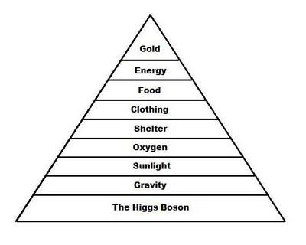](http://2.bp.blogspot.com/_cvdgPlEKW9k/SwhueFJriOI/AAAAAAAAA5Y/yyS7Xx8Ttt4/s1600/Full_Pyramid.jpg)  
Those in the financial industry have come to call this universal wealth asset (Gold) by the name "money," but that unnecessarily confuses the issue. In their efforts to facilitate various objectives in modern life, those in the financial industry endeavored to master the alchemist's craft--to methodically create "money" from such substances as worthless base metals or from paper. Even the village idiot can clearly see that "the bankers and others" didn't succeed in creating Gold. But the village idiots were never so sure that these nickel coins and paper notes weren't in fact successfully turned into this other *thing* that the experts called "*money*." As for me, I'm comfortable calling these lesser creations by the name "currency," and further, I recognize that they can and do serve a useful purpose in modern society. With this distinction I am not so easily baffled as the village idiots into thinking that these currencies created in the image of "real money" can actually attain the superior wealth function of the asset they sought to imitate--that being Gold. And you shouldn't be fooled either.  
  
Every currency made in imitation of Gold goes hand in hand with the financial architecture that supports it right into the trashbin of failed efforts, and are logged into the collective wisdom of those who vow not to be fooled again. Based on the "conception, care, and feeding" of the various currencies and their supporting architectures, the life span--or timeline--of predictable rise and fall milestones may vary in length from one currency to another. They may serve a purpose while they last, but they all suffer the same eventual demise at the hands of inflation. Remember, these currencies are man's artificial attempt, time and time again, to imitate Gold for use in modern commerce. They are built for speed--built to be borrowed specifically, and spent rapidly! They are not suitable for saving. For that you must turn to the master--the near-wealth proxy upon which all currencies must bow down in inferior imitation.  
  
So you see, learning how the world works is all about each man coming to the understanding about the real wealth we all require to best ensure our survival. Knowing that Gold is the master proxy for our life's day-to-day and year-to-year shifting requirements for food, clothing, shelter, and energy, it simply makes more sense to gather in Gold for later use than to gather in clothes (that we may outgrow,) food (that may spoil,) houses which are more than our needs, or energy (that we can't store.) You see, time bears witness to this undeniable fact: Gold can be called wealth because it is an enduring wealth proxy in exchange for our life's needs. Currency, on the other hand, serves a specific modern economic purpose--to be borrowed and inflated in placation of man's immediate desires. It is not wealth, it fails as a proxy for the Gold it tries to imitate. Do not confuse the two.  
  
I think we can chop off the bottom four "foundational" layers of our pyramid now, since they are in full supply. Let's think of them as the solid ground upon which this wealth pyramid stands.  
  
[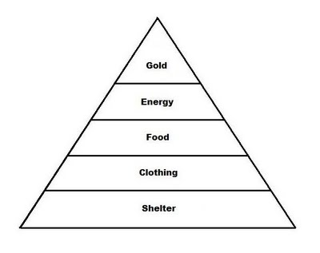](http://4.bp.blogspot.com/_cvdgPlEKW9k/SwhuptFjskI/AAAAAAAAA5g/82nfWzG_l_Y/s1600/Wealth_Pyramid.jpg)  
Now that we have established a solid pyramid of life's necessities and the need for a pure wealth concept in order to secure a future supply, let us take another look at John Exter's inverse pyramid of paper products based on wealth derivatives. I first introduced this concept on my blog in the post called [All Paper is STILL a short position on gold](http://fofoa.blogspot.com/2009/03/all-paper-is-still-short-position-on.html). And by the way, George Washington himself [5] helpfully pointed out that the image I used, from Wikipedia, may *not* be the correct Exter pyramid. Perhaps Trace Mayer's pyramid [6] is better. In any case, let's make a fresh one for our conceptual purposes:  
  
[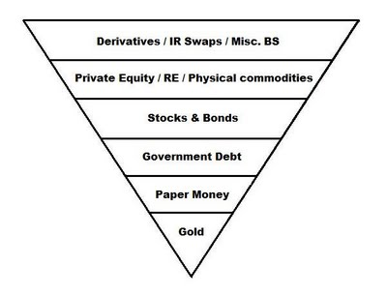](http://3.bp.blogspot.com/_cvdgPlEKW9k/Swhu0d3nnbI/AAAAAAAAA5o/Nvb20b4xDnQ/s1600/Inverse_Pyramid.jpg)  
Next, let us place this paper derivative inverse pyramid atop the real wealth pyramid. Let's see how it looks!  
  
[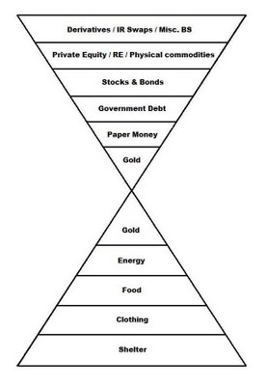](http://4.bp.blogspot.com/_cvdgPlEKW9k/Swhu9b60zoI/AAAAAAAAA5w/Wf5OLd-66KI/s1600/Dual_Pyramids.jpg)  
Does it look a little like an hourglass?  
  
[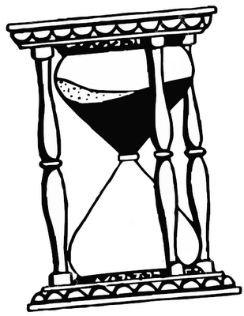](http://4.bp.blogspot.com/_cvdgPlEKW9k/SwhvF3OOAOI/AAAAAAAAA54/xnUMP0HDE-Y/s1600/Hourglass.png)  
Now picture this. The inverse pyramid on top is actually ten (10) times larger than the pyramid on the bottom. And it is 100 to 200 times larger than the golden capstone!  
  
[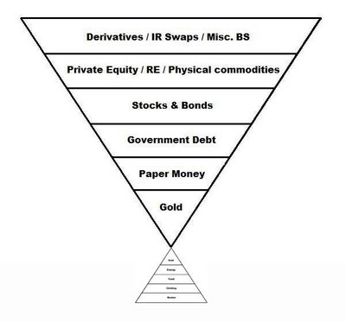](http://1.bp.blogspot.com/_cvdgPlEKW9k/SwhvOhHU1oI/AAAAAAAAA6A/6SDcsbJeIOc/s1600/10X_Pyramid.jpg)  
In ancient times gold was the very best item for trading and as such, it became the very best wealth reserve. Later, gold became currency and came to be known as money. Today, gold is commonly believed to be only a commodity and is traded as such.  
  
I propose to you that we can estimate that

1. as a mere commodity today, gold is relegated to a trading range of between $700 and $5,000.
2. As a currency, which it has not been since at least 1933, it would be range-bound between $4,000 and $11,000 according to Jim Rickards. [7]
3. And set free to fill its ancient role as a wealth reserve, gold will rise to somewhere between $10,000 and $100,000 in today's dollars.

Be wary of the "men's suit comparison". Just a couple hundred years ago a wealthy man amidst 1 billion others on this planet might have had a handful of fine men's suits, a nice house and a large plantation. Today a wealthy man would have dozens of fine suits, a couple mansions, a large yacht, 29 flat screen TV's, an iPhone, and a sizable paper-wealth trading account. And that is among 6.75 billion souls on the planet. Compare wealth with wealth, not suits with suits.  
  
Can you imagine a gold price of AT LEAST $100,000 per ounce? How about a real purchasing power increase, measured in today's dollar purchasing power, to somewhere between $10,000 and $100,000? In the bell curve below we can see that the most probable PP landing zone is between $25,000 per troy ounce and $85,000 per troy ounce. Can you think of a better reason to invest in physical gold coins right now? How about protection from hyperinflation? $100,000 is the bare minimum in this case. The top is infinite! Imagine $12 trillion per troy ounce... the size of today's US national debt reduced to one single gold coin you could buy tomorrow! Can you imagine it? It doesn't really matter if you can't see it like I do, as long as you buy the coin. As JFK liked to say, "a rising tide lifts all boats", not just the ones that believe in rising tides.  
  
[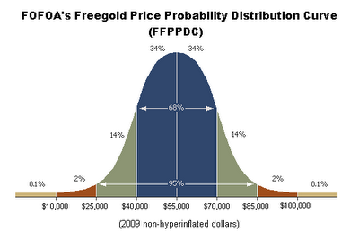](http://3.bp.blogspot.com/_cvdgPlEKW9k/SwhvYm7eIRI/AAAAAAAAA6I/bx9LxOlO6yo/s1600/Freegold_bellcurve.gif)  
You don't have to buy my story as long as you buy gold!  
  
Sincerely,  
FOFOA  
  
[[1]](http://fofoa.blogspot.com/2009/10/gold-is-money.html) Gold is Money - Part 1  
[[2]](http://fofoa.blogspot.com/2009/10/gold-is-money-part-2.html) Gold is Money - Part 2  
[[3]](http://fofoa.blogspot.com/2009/10/gold-is-money-part-3.html) Gold is Money - Part 3  
[[4]](http://www.usagold.com/hall/hallfame2.html#anchor1588010) Full credit goes to Aristotle for his acute clarity of Thought. Sir Ari, where are you?  
[[5]](http://www.nakedcapitalism.com/2009/09/guest-post.html#comment-57575) The first president of the USA converses with FOFOA  
[[6]](http://www.creditcontraction.com/images/affiliate/Great-Credit-Contraction-Liquidity-Pyramid-Large.jpg) The Great Credit Contraction Liquidity Pyramid - By Trace Mayer  
[[7]](http://www.cnbc.com/id/15840232?video=1336090735&play=1) Jim Rickards on CNBC's SquawkBox, 11/19/09

Posted by FOFOA at [2:39 PM](http://fofoa.blogspot.com/2009/11/gold-is-wealth.html)

**222 comments:**

[«Oldest](http://fofoa.blogspot.com/2009/11/gold-is-wealth.html?commentPage=1)   [‹Older](http://fofoa.blogspot.com/2009/11/gold-is-wealth.html?commentPage=0)   1 – 200 of 222   [Newer›](http://fofoa.blogspot.com/2009/11/gold-is-wealth.html?commentPage=2)   [Newest»](http://fofoa.blogspot.com/2009/11/gold-is-wealth.html?commentPage=2)

http://www.blogger.com/img/blank.gif

Anonymous said...

Compelling construct FOFOA. Closely akin to Maslow's pyramid of human needs where gold would be part of the base. Funny after all these centuries that alchemists's have once again reared their ugly, sallow heads with tungsten... and of course FRN's since 1913.  
  
No need to worry though, Mish/Shedlock on Max Keiser tells us that things wont be nearly as bad as the Great depression because the "strength of the social services safety net." He cites the widespread provision of food stamps (did I recently read 25-50% of US children "nourished" by foodstamps today?) and the announcement that fannie will lease housing to the homeless etc.   
  
What a bizarre claim, even Kaiser challenges the food stamp rationale with incredulity. Beware false prophets like Mish!  
  
Vis a vis "other" hard assets such as agricultural land, I came across the statistic (thecomingdepression.blogspot.com) that 60% of farms were seized by banks in the 1930's when the shtf. Look for far more this time around.  
  
  
BGR

[November 21, 2009 3:45 PM](http://fofoa.blogspot.com/2009/11/gold-is-wealth.html?showComment=1258847143582#c6429351589044689043) [http://www.blogger.com/img/icon_delete13.gif](http://www.blogger.com/delete-comment.g?blogID=4490468598422095060&postID=6429351589044689043)

http://www.blogger.com/img/blank.gif

http://www.blogger.com/img/blank.gif

Anonymous said...

Yes,  
  
here is an article written in Sept 2004 - about Gold during the Medici banking days of the 15th century.   
  
<http://www.safehaven.com/article-1922.htm>   
  
1 ounce back then had the purchasing power of $35,000US in 2004 dollar terms.  
  
Gold has been there before and will return.....  
  
there is nothing new under the sun.

[November 21, 2009 4:52 PM](http://fofoa.blogspot.com/2009/11/gold-is-wealth.html?showComment=1258851124533#c8892184026858872179) [http://www.blogger.com/img/icon_delete13.gif](http://www.blogger.com/delete-comment.g?blogID=4490468598422095060&postID=8892184026858872179)

http://www.blogger.com/img/blank.gif

[http://www.blogger.com/img/b16-rounded.gif](http://www.blogger.com/profile/14997207971100454061)

[Museice](http://www.blogger.com/profile/14997207971100454061) said...

I needed to be reminded of this.  
  
"In Austrian teaching, money originates in the market: …all money has originated, and must originate, in a useful commodity chosen by the free market as a medium of exchange. The unit of money is basically just a unit of weight of the monetary commodity – usually a metal, such as gold or silver. Government has no role in the definition or selection of money, let alone its creation, price or quantity. That is the market’s function.  
  
In Keynesian theory, by contrast, money originates in the state. Government has a total monopoly on money, starting with its very definition. It is not chosen in free exchange, it is imposed by force."   
http://www.goldensextant.com/

[November 22, 2009 8:11 AM](http://fofoa.blogspot.com/2009/11/gold-is-wealth.html?showComment=1258906282850#c377220379040940169) [http://www.blogger.com/img/icon_delete13.gif](http://www.blogger.com/delete-comment.g?blogID=4490468598422095060&postID=377220379040940169)

[http://www.blogger.com/img/b16-rounded.gif](http://www.blogger.com/profile/14997207971100454061)

[Museice](http://www.blogger.com/profile/14997207971100454061) said...

Here's the link without 'frames'.  
  
['Viva la Restoration' Remarks of Robert K. Landis](http://www.goldensextant.com/RKLSage.html#anchor1404)  
  
Reminds me of a speech you would give FOFOA

[November 22, 2009 8:22 AM](http://fofoa.blogspot.com/2009/11/gold-is-wealth.html?showComment=1258906953202#c4861733940529328985) [http://www.blogger.com/img/icon_delete13.gif](http://www.blogger.com/delete-comment.g?blogID=4490468598422095060&postID=4861733940529328985)

http://www.blogger.com/img/blank.gif

Tekin said...

Revisiting Exter's Pyramid with estimated layer values:  
  
http://www.creditcontraction.com/images/affiliate/Great-Credit-Contraction-Liquidity-Pyramid-Large.jpg  
  
My understanding of the latest FOFOA post is that the upper layer (Derivatives: 1600 Trillions) shall not be honoured as wealth.   
  
Disregarding the upper layer (1600T) and recalculating the "equlibrium" gold price:  
  
(125+100+65+4)*1e12/(150000*1e6/31.10348)  
  
yields an answer of 61,000 Dollars per ounce which is quite close to FOFOA's midpoint estimate of 55,000 Dollars per ounce.  
  
Then one naturally asks; how shall the derivates be resolved?

[November 22, 2009 8:43 AM](http://fofoa.blogspot.com/2009/11/gold-is-wealth.html?showComment=1258908213333#c276397130375626067) [http://www.blogger.com/img/icon_delete13.gif](http://www.blogger.com/delete-comment.g?blogID=4490468598422095060&postID=276397130375626067)

[http://www.blogger.com/img/b16-rounded.gif](http://www.blogger.com/profile/10691085642452851905)

[Martijn](http://www.blogger.com/profile/10691085642452851905) said...

Interesting remark on money, Museice.

[November 22, 2009 9:00 AM](http://fofoa.blogspot.com/2009/11/gold-is-wealth.html?showComment=1258909214007#c3728798225621457643) [http://www.blogger.com/img/icon_delete13.gif](http://www.blogger.com/delete-comment.g?blogID=4490468598422095060&postID=3728798225621457643)

http://www.blogger.com/img/blank.gif

Anonymous said...

Tekin,  
  
Loven' that math bro!

[November 22, 2009 10:03 AM](http://fofoa.blogspot.com/2009/11/gold-is-wealth.html?showComment=1258912999533#c5011807552053987290) [http://www.blogger.com/img/icon_delete13.gif](http://www.blogger.com/delete-comment.g?blogID=4490468598422095060&postID=5011807552053987290)

http://www.blogger.com/img/blank.gif

[http://www.blogger.com/img/b16-rounded.gif](http://www.blogger.com/profile/04496901575312017807)

[stibot](http://www.blogger.com/profile/04496901575312017807) said...

Tekin> i followed your formula which fits FOFOA's prediction. But i simply do not understand it, well perhaps you too. :-)  
  
Imagine there's village ("the World") of 5 people, each has 1 gramm of gold in possession but you have 1 kg. So according to formula: all the wealth in the village costs 1,004 kg, which is aprox. 1 kg.  
  
But you can not expect you put your 1 kg on the table and you become the owner of all the things in the village. Apart from the fact there is also silver (and this and that..) as money, not all the wealth is for sell at this price. Maybe they agree to sell for mere gramm but maybe they are not going to sell at all.  
  
So i consider such formula as a flaw.

[November 22, 2009 10:36 AM](http://fofoa.blogspot.com/2009/11/gold-is-wealth.html?showComment=1258914976288#c7173542194341713325) [http://www.blogger.com/img/icon_delete13.gif](http://www.blogger.com/delete-comment.g?blogID=4490468598422095060&postID=7173542194341713325)

http://www.blogger.com/img/blank.gif

[http://www.blogger.com/img/b16-rounded.gif](http://www.blogger.com/profile/14671034491715200986)

[Blindweb](http://www.blogger.com/profile/14671034491715200986) said...

I agree with Fofoa and have learned a lot from him, **except** there's one important thing missing. The civilizations of the earth are already in **overshoot** in terms of their resource base. Real wealth is going to be in permanent decline for at least century. The real wealth curve will provide an ever falling upper bound for gold. The population will peak and decline as well due to resource scarcity. Understanding peak oil is at least as important as free gold. It's always the thing you don't see that gets you, not the thing you're an expert on. This is the best peak oil blog I know of <http://thearchdruidreport.blogspot.com/>

[November 22, 2009 12:00 PM](http://fofoa.blogspot.com/2009/11/gold-is-wealth.html?showComment=1258920053032#c1749087424557713720) [http://www.blogger.com/img/icon_delete13.gif](http://www.blogger.com/delete-comment.g?blogID=4490468598422095060&postID=1749087424557713720)

http://www.blogger.com/img/blank.gif

http://www.blogger.com/img/blank.gif

Tekin said...

@ stibot  
  
One cannot make a perfect model of reality. All models have assumptions and simplifications. In the Exter's inverted pyramid model, creditors try to move down the debt pyramid.  
  
In Exter's own words:  
  
"[Debt is] what my upside-down debt pyramid is all about...The debt burden at some point becomes unsustainable...creditors in the debt pyramid will move down the pyramid... Creditors will try to get out of those weak debtors & go down the debt pyramid, to the very bottom: currency (dollar bills), even though they pay no interest. Next above currency are Treasury bills, issued by the government & backed by the Federal Reserve, which supports the market through its open market operations. They are by far the largest component of Reserve Bank credit, so are really as safe as currency notes, plus they pay interest. Still, you can’t buy anything with Treasury bills; you have to liquidate the bills to get money of some sort to buy something...The final step down is out of the debt pyramid altogether into gold."  
  
I am trying to investigate the logical results of the model. Namely, if the model is true, what would be consequences.

[November 22, 2009 1:52 PM](http://fofoa.blogspot.com/2009/11/gold-is-wealth.html?showComment=1258926740509#c4451343847273761988) [http://www.blogger.com/img/icon_delete13.gif](http://www.blogger.com/delete-comment.g?blogID=4490468598422095060&postID=4451343847273761988)

[http://www.blogger.com/img/b16-rounded.gif](http://www.blogger.com/profile/17152544684132776239)

[FOFOA](http://www.blogger.com/profile/17152544684132776239) said...

@ TomB,  
  
I do not know about the Euro. But perhaps [this](http://1.bp.blogspot.com/_cvdgPlEKW9k/Swnl4sfbMLI/AAAAAAAAA6Y/jduYOIVfyvA/s1600/Freegold_bellcurve_oil.gif) will help to disambiguate a point illustrated through a poor yardstick.  
  
Sincerely,  
FOFOA

[November 22, 2009 5:35 PM](http://fofoa.blogspot.com/2009/11/gold-is-wealth.html?showComment=1258940152131#c5356260297963658110) [http://www.blogger.com/img/icon_delete13.gif](http://www.blogger.com/delete-comment.g?blogID=4490468598422095060&postID=5356260297963658110)

[http://www.blogger.com/img/b16-rounded.gif](http://www.blogger.com/profile/02422604006082536504)

[SatyaPranava](http://www.blogger.com/profile/02422604006082536504) said...

this is a tough question (at least for me). But presuming we're in the wild west, and we're looking out the upper window and we see our rival has 2 full revolvers, each with six bullets.   
  
Considering all the paper that is being pushed (and we know it's at least 23.7 trillion), how many bullets is that? what can that money really buy (if not just about everything), and when can we have a good indication our rival is down to the last bullet or two?

[November 22, 2009 6:25 PM](http://fofoa.blogspot.com/2009/11/gold-is-wealth.html?showComment=1258943114593#c3085550778562531604) [http://www.blogger.com/img/icon_delete13.gif](http://www.blogger.com/delete-comment.g?blogID=4490468598422095060&postID=3085550778562531604)

[http://www.blogger.com/img/b16-rounded.gif](http://www.blogger.com/profile/17932860172715556937)

[costata](http://www.blogger.com/profile/17932860172715556937) said...

Satya,  
  
Re: Food Security  
  
<http://www.commodityonline.com/news/49-mn-Americans-food-insecure-USDA-study-23012-3-1.html>   
  
Sorry for the delay in getting back to you. I had to earn my daily bread.  
  
You might consider visiting another site from time to time. Eric deCarbonnel does a great job aggregating news about the commodity (food) markets. This could give you an early warning system for your food programs.  
  
<http://www.marketskeptics.com/>

[November 22, 2009 8:33 PM](http://fofoa.blogspot.com/2009/11/gold-is-wealth.html?showComment=1258950792471#c5845750466560175564) [http://www.blogger.com/img/icon_delete13.gif](http://www.blogger.com/delete-comment.g?blogID=4490468598422095060&postID=5845750466560175564)

http://www.blogger.com/img/blank.gif

Tekin said...

Exter was anticipating deflation - however we have TARP etc. Central Banks are monetizing all the assets at the upper layers. Perhaps, the formulation should be: "Gold will reach 55,000 dollars in todays dollars and, additionally, we shall have %600 cumulative inflation"?!

[November 23, 2009 12:34 AM](http://fofoa.blogspot.com/2009/11/gold-is-wealth.html?showComment=1258965241214#c2077616444765137133) [http://www.blogger.com/img/icon_delete13.gif](http://www.blogger.com/delete-comment.g?blogID=4490468598422095060&postID=2077616444765137133)

http://www.blogger.com/img/blank.gif

Anonymous said...

Mortymer:  
About the last article...   
- The oil is missing from it and it gets the whole stuff very complicated.  
- Oil = gold? Same level?  
- Please lets not be too gold centric and leave the space for black gold as well.  
- One note: the dollar market for oil goes down but there are other markets rising,.

[November 23, 2009 12:58 AM](http://fofoa.blogspot.com/2009/11/gold-is-wealth.html?showComment=1258966681292#c7962224039620782408) [http://www.blogger.com/img/icon_delete13.gif](http://www.blogger.com/delete-comment.g?blogID=4490468598422095060&postID=7962224039620782408)

[http://www.blogger.com/img/b16-rounded.gif](http://www.blogger.com/profile/10691085642452851905)

[Martijn](http://www.blogger.com/profile/10691085642452851905) said...

Doesn't [this graph](http://4.bp.blogspot.com/_pMscxxELHEg/SweFiaBtVQI/AAAAAAAAG2E/aqcCv0hLBX4/s1600/BankFailuresperYearNov.jpg) show you how far we've traveled and how much there is left to go?

[November 23, 2009 1:05 AM](http://fofoa.blogspot.com/2009/11/gold-is-wealth.html?showComment=1258967140818#c7165473569282774503) [http://www.blogger.com/img/icon_delete13.gif](http://www.blogger.com/delete-comment.g?blogID=4490468598422095060&postID=7165473569282774503)

[http://www.blogger.com/img/b16-rounded.gif](http://www.blogger.com/profile/10691085642452851905)

[Martijn](http://www.blogger.com/profile/10691085642452851905) said...

@Mortymer  
  
If ANOTHER and FOA were right we should indeed not loose sight of oil

[November 23, 2009 1:40 AM](http://fofoa.blogspot.com/2009/11/gold-is-wealth.html?showComment=1258969243410#c2844535634478117093) [http://www.blogger.com/img/icon_delete13.gif](http://www.blogger.com/delete-comment.g?blogID=4490468598422095060&postID=2844535634478117093)

[http://www.blogger.com/img/b16-rounded.gif](http://www.blogger.com/profile/02422604006082536504)

[SatyaPranava](http://www.blogger.com/profile/02422604006082536504) said...

@costata:  
  
i've been folowing EDC's site for well over a year now. but he tends to focus more specifically on harvest projections, etc.   
  
thanks very much for the link, and also for the for the suggestion!  
  
satya

[November 23, 2009 2:14 AM](http://fofoa.blogspot.com/2009/11/gold-is-wealth.html?showComment=1258971263454#c4798030670111958920) [http://www.blogger.com/img/icon_delete13.gif](http://www.blogger.com/delete-comment.g?blogID=4490468598422095060&postID=4798030670111958920)

http://www.blogger.com/img/blank.gif

http://www.blogger.com/img/blank.gif

Anonymous said...

Mortymer:  
Martinj, please note that the amount of banks changed so better would be the percentage change. Then, people started to use credit cards -> and sooner or later got to minus -> which is kind of default itself => banks were melted dispersed into impersonal personal plastic card/credit creators eating them alive. It is funny, like Lenin once told that capitalism will sell the rope for hanging itself :o)  
Once my professor of markets told really smart thing: "Unless those Rating Agencies stand all stands." They shake now but they stand.  
Treasury still stands and sells its paper.

[November 23, 2009 3:46 AM](http://fofoa.blogspot.com/2009/11/gold-is-wealth.html?showComment=1258976798169#c5373485038419572080) [http://www.blogger.com/img/icon_delete13.gif](http://www.blogger.com/delete-comment.g?blogID=4490468598422095060&postID=5373485038419572080)

http://www.blogger.com/img/blank.gif

[http://www.blogger.com/img/b16-rounded.gif](http://www.blogger.com/profile/17932860172715556937)

[costata](http://www.blogger.com/profile/17932860172715556937) said...

Satya,  
  
Denninger has a graph and commentary on Market Ticker that addresses this issue. I have seen the graph before but it is not attributed by Denninger (could be from Chris Martenson).  
  
EVERYONE the article linked below could be a must read.  
  
<http://www.zerohedge.com/article/albert-edwards-calls-next-black-swan-expect-yuan-devaluation-following-deep-2010-downturn>   
  
The Soc Gen analyst posits a yuan DEVALUATION in 2010. Tyler Durden calls this a black swan that would completely confound the forex algorithms of traders.  
  
Does anyone think this is credible?  
  
How would this impact on the progress to Freegold?  
  
Would this be a desirable development from the perspective of the Euro project sponsors?  
  
I am mulling this over and I will try to contribute if anyone thinks this is worth discussing.

[November 23, 2009 3:36 PM](http://fofoa.blogspot.com/2009/11/gold-is-wealth.html?showComment=1259019379105#c5408252222259990920) [http://www.blogger.com/img/icon_delete13.gif](http://www.blogger.com/delete-comment.g?blogID=4490468598422095060&postID=5408252222259990920)

[«Oldest](http://fofoa.blogspot.com/2009/11/gold-is-wealth.html?commentPage=1) [‹Older](http://fofoa.blogspot.com/2009/11/gold-is-wealth.html?commentPage=0)   1 – 200 of 222   [Newer› Newest»](http://fofoa.blogspot.com/2009/11/gold-is-wealth.html?commentPage=2)

[Post a Comment](https://www.blogger.com/comment.g?blogID=4490468598422095060&postID=4177983190120730088&isPopup=true)

**Links to this post**